**Introduction**

Name – Mohammad Sahil

ECE – 6th Sem

Project name – Implementing FreeRTOS on STM32

**Here is a comparison between General-Purpose Operating Systems (GPOS) and Real-Time Operating Systems (RTOS):**

| **Feature** |  |  | **General-Purpose Operating System (GPOS)** | **Real-Time Operating System (RTOS)** |
| --- | --- | --- | --- | --- |
| **Purpose** |  |  | Designed for general computing tasks like desktop applications, gaming, and browsing. | Designed for time-critical applications like robotics, avionics, and industrial automation. |
| **Responsiveness** |  |  | Prioritizes high throughput and user experience. May have unpredictable delays. | Ensures predictable and deterministic response to events. |
| **Task Scheduling** |  |  | Non-deterministic scheduling (e.g., time-sharing, round-robin, or priority-based). | Deterministic scheduling, often using fixed-priority or pre-emptive algorithms. |
| **Latency** |  |  | Can tolerate higher latency for tasks. | Low and predictable latency is critical for real-time operations. |
| **Pre-emption** |  |  | Tasks may not be pre-empted immediately, leading to delays. | Supports immediate pre-emption to meet real-time deadlines. |
| **Resource Management** |  |  | Optimized for general efficiency and multitasking. | Optimized for timely resource allocation to critical tasks. |
| **Interrupt Handling** |  |  | Can have delayed interrupt handling due to lower priority mechanisms. | Interrupts are handled promptly with minimal latency. |
| **Example Use Cases** |  |  | Desktops, smartphones, servers (e.g., Windows, macOS, Linux). | Embedded systems, medical devices, automotive systems (e.g., FreeRTOS, VxWorks). |
| **Error Tolerance** |  |  | Designed to recover from crashes without stringent real-time guarantees. | Focused on high reliability with fault-tolerance mechanisms. |
| **Hardware Requirements** |  |  | May require higher memory and processing power. | Designed to run efficiently on resource-constrained devices. |
| **Cost** |  |  | May have higher costs depending on licensing and hardware needs. | Often lightweight and tailored for specific hardware, reducing cost. |

* **Objective**: To implement FreeRTOS on STM32 Blue Pill for efficient multitasking and real-time performance.
* **What is FreeRTOS?**
  + FreeRTOS is an open-source real-time operating system designed for embedded systems.
  + Provides multitasking capabilities, resource management, and synchronization mechanisms.

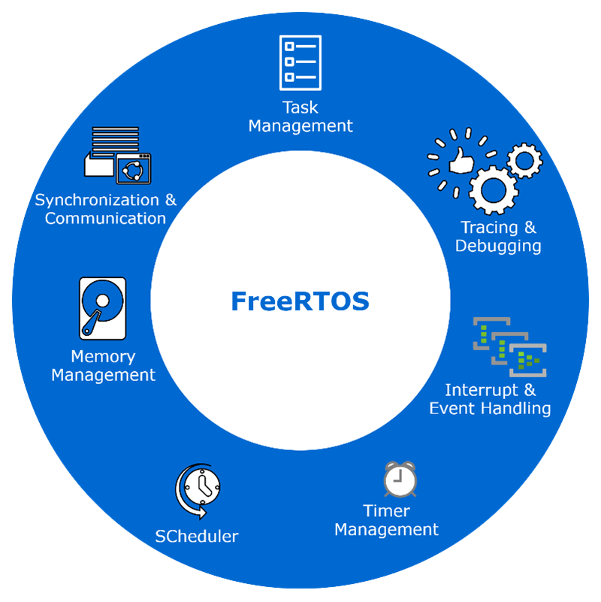

* **What is STM32 Blue Pill?**
  + A low-cost development board based on the STM32F103C8T6 microcontroller.
  + Features include a 72 MHz ARM Cortex-M3 core, 64 KB Flash memory, and 20 KB SRAM.
  + 3 Uart, 3 Spi,2 CAN,2 I2c.

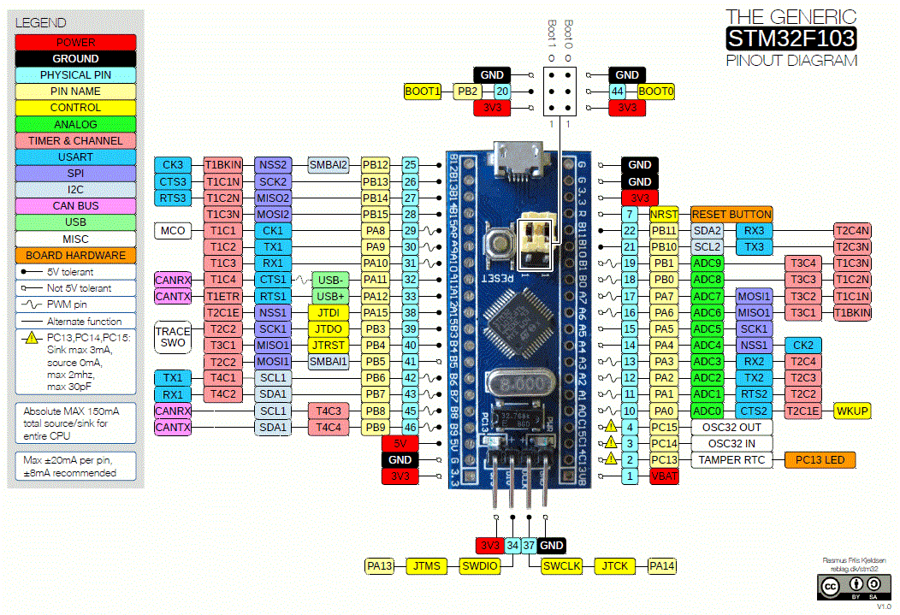

**: Why Use FreeRTOS on STM32?**

* Efficient multitasking: Enables running multiple tasks simultaneously.
* Real-time performance: Provides predictable behaviour for time-sensitive applications.
* Hardware abstraction: Simplifies hardware management.

**Hardware Requirements**

The hardware listed are suited for the following project and listed source code

Though you can use any component you want by tweaking the source code

* ST-Link V2 programmer
* Bluepill board
* A servo
* Some LEDs (optional)

**IOC FILE**

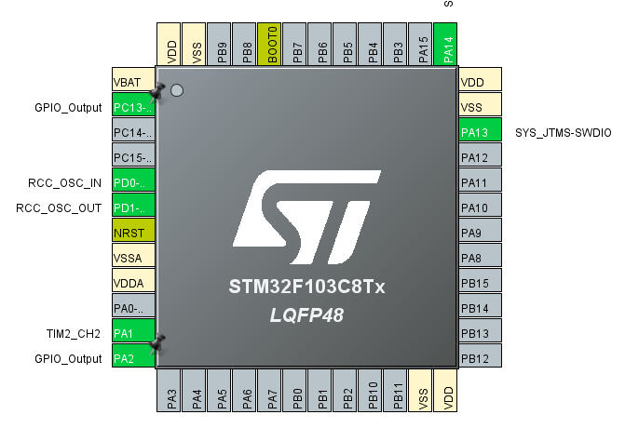

In STM32 Cube IDE, an "IOC file" refers to a project configuration file generated by the STM32CubeMX tool, which stores all the settings related to your microcontroller's peripheral initialization, pin assignments, and clock configuration, essentially acting as a central hub for managing your device's low-level settings within the development environment; allowing for easy code generation and project management

**Schematic**

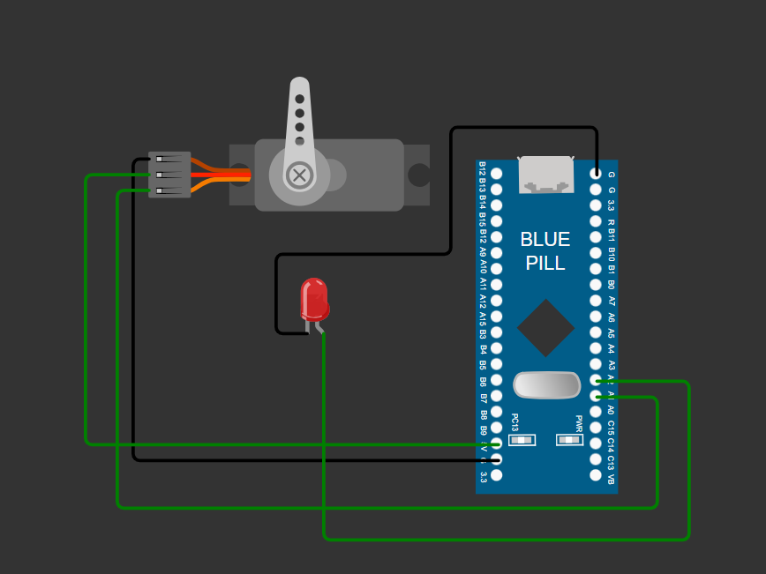

**Power given externally to the servo**

As Blue pill is operating upon 3.3V which is not sufficient for the servo as they are designed to operate between 4.8 to 6 V (SG90).

**CODE**

/* USER CODE BEGIN Header */

/**

******************************************************************************

* @file : main.c

* @brief : Main program body

******************************************************************************

* @attention

*

* Copyright (c) 2025 STMicroelectronics.

* All rights reserved.

*

* This software is licensed under terms that can be found in the LICENSE file

* in the root directory of this software component.

* If no LICENSE file comes with this software, it is provided AS-IS.

*

******************************************************************************

*/

/* USER CODE END Header */

/* Includes ------------------------------------------------------------------*/

#include "main.h"

#include "cmsis_os.h"

/* Private includes ----------------------------------------------------------*/

/* USER CODE BEGIN Includes */

/* USER CODE END Includes */

/* Private typedef -----------------------------------------------------------*/

/* USER CODE BEGIN PTD */

/* USER CODE END PTD */

/* Private define ------------------------------------------------------------*/

/* USER CODE BEGIN PD */

/* USER CODE END PD */

/* Private macro -------------------------------------------------------------*/

/* USER CODE BEGIN PM */

/* USER CODE END PM */

/* Private variables ---------------------------------------------------------*/

TIM_HandleTypeDef htim2;

osThreadId Blink1Handle;

osThreadId BLINK_2Handle;

osThreadId Servo_ControlHandle;

/* USER CODE BEGIN PV */

/* USER CODE END PV */

/* Private function prototypes -----------------------------------------------*/

void SystemClock_Config(void);

static void MX_GPIO_Init(void);

static void MX_TIM2_Init(void);

void GREEN_LED(void const * argument);

void WHITE_LED(void const * argument);

void Servo(void const * argument);

/* USER CODE BEGIN PFP */

/* USER CODE END PFP */

/* Private user code ---------------------------------------------------------*/

/* USER CODE BEGIN 0 */

/* USER CODE END 0 */

/**

* @brief The application entry point.

* @retval int

*/

int main(void)

{

/* USER CODE BEGIN 1 */

/* USER CODE END 1 */

/* MCU Configuration--------------------------------------------------------*/

/* Reset of all peripherals, Initializes the Flash interface and the Systick. */

HAL_Init();

/* USER CODE BEGIN Init */

/* USER CODE END Init */

/* Configure the system clock */

SystemClock_Config();

/* USER CODE BEGIN SysInit */

/* USER CODE END SysInit */

/* Initialize all configured peripherals */

MX_GPIO_Init();

MX_TIM2_Init();

/* USER CODE BEGIN 2 */

HAL_TIM_PWM_Start(&htim2,TIM_CHANNEL_2);

/* USER CODE END 2 */

/* USER CODE BEGIN RTOS_MUTEX */

/* add mutexes, ... */

/* USER CODE END RTOS_MUTEX */

/* USER CODE BEGIN RTOS_SEMAPHORES */

/* add semaphores, ... */

/* USER CODE END RTOS_SEMAPHORES */

/* USER CODE BEGIN RTOS_TIMERS */

/* start timers, add new ones, ... */

/* USER CODE END RTOS_TIMERS */

/* USER CODE BEGIN RTOS_QUEUES */

/* add queues, ... */

/* USER CODE END RTOS_QUEUES */

/* Create the thread(s) */

/* definition and creation of Blink1 */

osThreadDef(Blink1, GREEN_LED, osPriorityNormal, 0, 128);

Blink1Handle = osThreadCreate(osThread(Blink1), NULL);

/* definition and creation of BLINK_2 */

osThreadDef(BLINK_2, WHITE_LED, osPriorityNormal, 0, 128);

BLINK_2Handle = osThreadCreate(osThread(BLINK_2), NULL);

/* definition and creation of Servo_Control */

osThreadDef(Servo_Control, Servo, osPriorityNormal, 0, 128);

Servo_ControlHandle = osThreadCreate(osThread(Servo_Control), NULL);

/* USER CODE BEGIN RTOS_THREADS */

/* add threads, ... */

/* USER CODE END RTOS_THREADS */

/* Start scheduler */

osKernelStart();

/* We should never get here as control is now taken by the scheduler */

/* Infinite loop */

/* USER CODE BEGIN WHILE */

while (1)

{

/* USER CODE END WHILE */

/* USER CODE BEGIN 3 */

}

/* USER CODE END 3 */

}

/**

* @brief System Clock Configuration

* @retval None

*/

void SystemClock_Config(void)

{

RCC_OscInitTypeDef RCC_OscInitStruct = {0};

RCC_ClkInitTypeDef RCC_ClkInitStruct = {0};

/** Initializes the RCC Oscillators according to the specified parameters

* in the RCC_OscInitTypeDef structure.

*/

RCC_OscInitStruct.OscillatorType = RCC_OSCILLATORTYPE_HSE;

RCC_OscInitStruct.HSEState = RCC_HSE_ON;

RCC_OscInitStruct.HSEPredivValue = RCC_HSE_PREDIV_DIV1;

RCC_OscInitStruct.HSIState = RCC_HSI_ON;

RCC_OscInitStruct.PLL.PLLState = RCC_PLL_ON;

RCC_OscInitStruct.PLL.PLLSource = RCC_PLLSOURCE_HSE;

RCC_OscInitStruct.PLL.PLLMUL = RCC_PLL_MUL2;

if (HAL_RCC_OscConfig(&RCC_OscInitStruct) != HAL_OK)

{

Error_Handler();

}

/** Initializes the CPU, AHB and APB buses clocks

*/

RCC_ClkInitStruct.ClockType = RCC_CLOCKTYPE_HCLK|RCC_CLOCKTYPE_SYSCLK

|RCC_CLOCKTYPE_PCLK1|RCC_CLOCKTYPE_PCLK2;

RCC_ClkInitStruct.SYSCLKSource = RCC_SYSCLKSOURCE_PLLCLK;

RCC_ClkInitStruct.AHBCLKDivider = RCC_SYSCLK_DIV1;

RCC_ClkInitStruct.APB1CLKDivider = RCC_HCLK_DIV2;

RCC_ClkInitStruct.APB2CLKDivider = RCC_HCLK_DIV1;

if (HAL_RCC_ClockConfig(&RCC_ClkInitStruct, FLASH_LATENCY_0) != HAL_OK)

{

Error_Handler();

}

}

/**

* @brief TIM2 Initialization Function

* @param None

* @retval None

*/

static void MX_TIM2_Init(void)

{

/* USER CODE BEGIN TIM2_Init 0 */

/* USER CODE END TIM2_Init 0 */

TIM_ClockConfigTypeDef sClockSourceConfig = {0};

TIM_MasterConfigTypeDef sMasterConfig = {0};

TIM_OC_InitTypeDef sConfigOC = {0};

/* USER CODE BEGIN TIM2_Init 1 */

/* USER CODE END TIM2_Init 1 */

htim2.Instance = TIM2;

htim2.Init.Prescaler = 31;

htim2.Init.CounterMode = TIM_COUNTERMODE_UP;

htim2.Init.Period = 9999;

htim2.Init.ClockDivision = TIM_CLOCKDIVISION_DIV1;

htim2.Init.AutoReloadPreload = TIM_AUTORELOAD_PRELOAD_DISABLE;

if (HAL_TIM_Base_Init(&htim2) != HAL_OK)

{

Error_Handler();

}

sClockSourceConfig.ClockSource = TIM_CLOCKSOURCE_INTERNAL;

if (HAL_TIM_ConfigClockSource(&htim2, &sClockSourceConfig) != HAL_OK)

{

Error_Handler();

}

if (HAL_TIM_PWM_Init(&htim2) != HAL_OK)

{

Error_Handler();

}

sMasterConfig.MasterOutputTrigger = TIM_TRGO_RESET;

sMasterConfig.MasterSlaveMode = TIM_MASTERSLAVEMODE_DISABLE;

if (HAL_TIMEx_MasterConfigSynchronization(&htim2, &sMasterConfig) != HAL_OK)

{

Error_Handler();

}

sConfigOC.OCMode = TIM_OCMODE_PWM1;

sConfigOC.Pulse = 0;

sConfigOC.OCPolarity = TIM_OCPOLARITY_HIGH;

sConfigOC.OCFastMode = TIM_OCFAST_DISABLE;

if (HAL_TIM_PWM_ConfigChannel(&htim2, &sConfigOC, TIM_CHANNEL_2) != HAL_OK)

{

Error_Handler();

}

/* USER CODE BEGIN TIM2_Init 2 */

/* USER CODE END TIM2_Init 2 */

HAL_TIM_MspPostInit(&htim2);

}

/**

* @brief GPIO Initialization Function

* @param None

* @retval None

*/

static void MX_GPIO_Init(void)

{

GPIO_InitTypeDef GPIO_InitStruct = {0};

/* USER CODE BEGIN MX_GPIO_Init_1 */

/* USER CODE END MX_GPIO_Init_1 */

/* GPIO Ports Clock Enable */

__HAL_RCC_GPIOC_CLK_ENABLE();

__HAL_RCC_GPIOD_CLK_ENABLE();

__HAL_RCC_GPIOA_CLK_ENABLE();

/*Configure GPIO pin Output Level */

HAL_GPIO_WritePin(GPIOC, GPIO_PIN_13, GPIO_PIN_RESET);

/*Configure GPIO pin Output Level */

HAL_GPIO_WritePin(GPIOA, GPIO_PIN_2, GPIO_PIN_RESET);

/*Configure GPIO pin : PC13 */

GPIO_InitStruct.Pin = GPIO_PIN_13;

GPIO_InitStruct.Mode = GPIO_MODE_OUTPUT_PP;

GPIO_InitStruct.Pull = GPIO_NOPULL;

GPIO_InitStruct.Speed = GPIO_SPEED_FREQ_LOW;

HAL_GPIO_Init(GPIOC, &GPIO_InitStruct);

/*Configure GPIO pin : PA2 */

GPIO_InitStruct.Pin = GPIO_PIN_2;

GPIO_InitStruct.Mode = GPIO_MODE_OUTPUT_PP;

GPIO_InitStruct.Pull = GPIO_NOPULL;

GPIO_InitStruct.Speed = GPIO_SPEED_FREQ_LOW;

HAL_GPIO_Init(GPIOA, &GPIO_InitStruct);

/* USER CODE BEGIN MX_GPIO_Init_2 */

/* USER CODE END MX_GPIO_Init_2 */

}

/* USER CODE BEGIN 4 */

/* USER CODE END 4 */

/* USER CODE BEGIN Header_GREEN_LED */

/**

* @brief Function implementing the Blink1 thread.

* @param argument: Not used

* @retval None

*/

/* USER CODE END Header_GREEN_LED */

void GREEN_LED(void const * argument)

{

/* USER CODE BEGIN 5 */

/* Infinite loop */

for(;;)

{

HAL_GPIO_TogglePin(GPIOC, GPIO_PIN_13);

osDelay(500);

}

/* USER CODE END 5 */

}

/* USER CODE BEGIN Header_WHITE_LED */

/**

* @brief Function implementing the BLINK_2 thread.

* @param argument: Not used

* @retval None

*/

/* USER CODE END Header_WHITE_LED */

void WHITE_LED(void const * argument)

{

/* USER CODE BEGIN WHITE_LED */

/* Infinite loop */

for(;;)

{

HAL_GPIO_TogglePin(GPIOA,GPIO_PIN_2);

osDelay(200);

}

/* USER CODE END WHITE_LED */

}

/* USER CODE BEGIN Header_Servo */

/**

* @brief Function implementing the Servo_Control thread.

* @param argument: Not used

* @retval None

*/

/* USER CODE END Header_Servo */

void Servo(void const * argument)

{

/* USER CODE BEGIN Servo */

/* Infinite loop */

for(;;)

{

for(int i=1000;i<2500;i=i+10)

{

__HAL_TIM_SET_COMPARE(&htim2,TIM_CHANNEL_2,i);

osDelay(10);

}

osDelay(1);

for(int i=2500;i>1000;i=i-10)

{

__HAL_TIM_SET_COMPARE(&htim2,TIM_CHANNEL_2,i);

osDelay(10);

}

}

/* USER CODE END Servo */

}

/**

* @brief Period elapsed callback in non blocking mode

* @note This function is called when TIM3 interrupt took place, inside

* HAL_TIM_IRQHandler(). It makes a direct call to HAL_IncTick() to increment

* a global variable "uwTick" used as application time base.

* @param htim : TIM handle

* @retval None

*/

void HAL_TIM_PeriodElapsedCallback(TIM_HandleTypeDef *htim)

{

/* USER CODE BEGIN Callback 0 */

/* USER CODE END Callback 0 */

if (htim->Instance == TIM3) {

HAL_IncTick();

}

/* USER CODE BEGIN Callback 1 */

/* USER CODE END Callback 1 */

}

/**

* @brief This function is executed in case of error occurrence.

* @retval None

*/

void Error_Handler(void)

{

/* USER CODE BEGIN Error_Handler_Debug */

/* User can add his own implementation to report the HAL error return state */

__disable_irq();

while (1)

{

}

/* USER CODE END Error_Handler_Debug */

}

#ifdef USE_FULL_ASSERT

/**

* @brief Reports the name of the source file and the source line number

* where the assert_param error has occurred.

* @param file: pointer to the source file name

* @param line: assert_param error line source number

* @retval None

*/

void assert_failed(uint8_t *file, uint32_t line)

{

/* USER CODE BEGIN 6 */

/* User can add his own implementation to report the file name and line number,

ex: printf("Wrong parameters value: file %s on line %d\r\n", file, line) */

/* USER CODE END 6 */

}

#endif /* USE_FULL_ASSERT */